**Fake News Detection Android APP**





**Presented By:**

**ABHISHEK KUMAR VERMA(1900290110003)**

**COMPUTER SCIENCE AND INFORMATION TECHNOLOGY -SEM 6 TH SEC “A”**

### INTRODUCTION



**Fake news** is false or misleading information presented as [news](https://en.wikipedia.org/wiki/News). It often has the aim of damaging the reputation of a person or entity, or making money

through [advertising](https://en.wikipedia.org/wiki/Advertising) revenue.

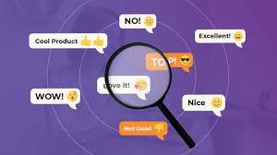

#### ABSTRACT



🠶 In our modern era where the internet is ubiquitous, everyone relies on various online resources for news.

🠶 Along with the increase in the use of social media platforms like Facebook, Twitter, etc. news spread rapidly among millions of users within a very short span of time.

🠶 The spread of fake news has far-reaching consequences like the creation of biased opinions to swaying election outcomes for the benefit of certain candidates.

🠶 Moreover, spammers use appealing news headlines to generate revenue using advertisements via click-baits.

🠶 In this ppt, we aim to perform binary classification of various news articles available online with the help of concepts pertaining to Artificial Intelligence, Natural Language Processing and Machine Learning.

🠶 We aim to provide the user with the ability to classify the news as fake or real and also check the authenticity of the website publishing the news.

## Objective



🠶 The project mainly deals analysis of news from various news websites.

🠶 Our Main objective is to get the overall correctness of news for a

particular topic based on its correctness probability.

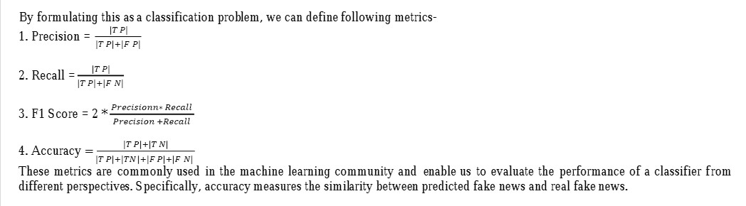

**GOALS**



In FAKE DETECTOR, the fake news

detection problem is formulated as

a **credibility score inference problem**, and FAKEDETECTOR aims at learning a prediction model to infer the credibility labels of news articles, creators and subjects simultaneously.

Social media and news outlets publish fake news to increase readership or as part of psychological warfare.

In general, the goal is profiting through clickbaits. Clickbaits lure users and entice curiosity with flashy headlines or designs to click links to increase advertisements revenues.

#### METHODOLOGY



🠶 This ppt explains the system which is developed in three parts.

The first part is static which works on machine learning

classifier.

🠶 We studied and trained the model with 4 different classifiers and chose the best classifier for final execution.

🠶 The second part is dynamic which takes the keyword/text from user and searches online for the truth probability of the news.

🠶 The third part provides the authenticity of the text input by user.we have used Python and its tflite libraries.

🠶 Python has a huge set of libraries and extensions, which can be easily used in Machine Learning.

🠶 tflite Learn library is the best source for machine learning algorithms where nearly all types of machine learning algorithms are readily available for Python, thus easy and quick evaluation of ML algorithms is possible.

##### DATA Collection and Analysis



We can get online news from different sources like social media websites, search engine, homepage of news agency websites or the fact-checking websites. On the Internet, there are a few publicly available datasets for Fake news classification like Buzzfeed News, LIAR , BS Detector kaggle etc

We used built-in Kaggle datasets for fake and genuine news.

Kaggle allows **users to find and publish data sets, explore and build models in** a web-based data-science environment, work with other data scientists and machine learning engineers, and enter competitions to solve data science challenges

The folder has two files; (1) fakeNews.csv, and (2) trueNews.csv. The data in .csv files contain the news article and the corresponding fake rating collected from the USA, India, and Europe regions.

train.csv: A full training dataset with the following attributes: id: unique id for a news article

title: the title of a news article author: author of the news article

text: the text of the article; could be incomplete

label: a label that marks the article as potentially unreliable

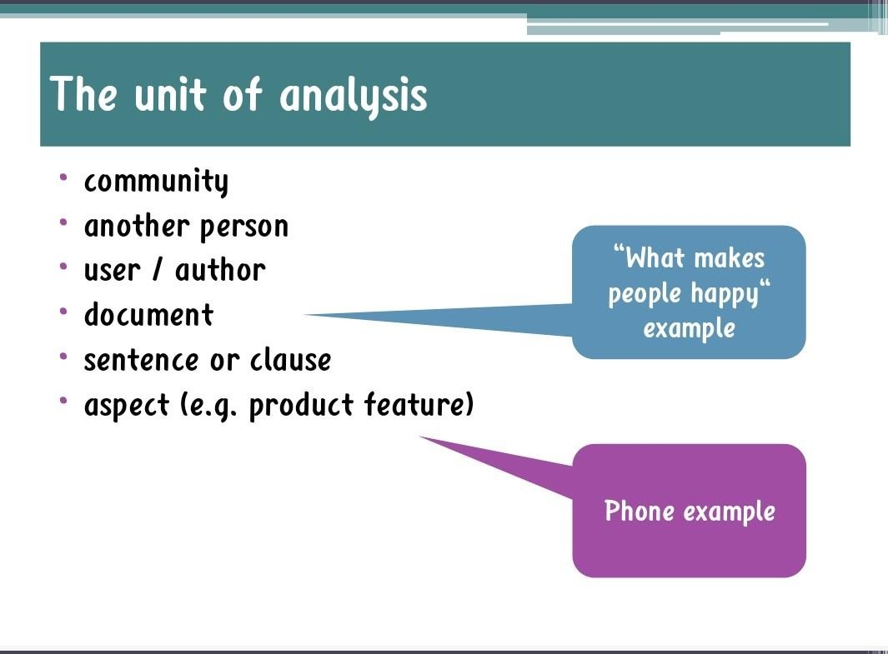



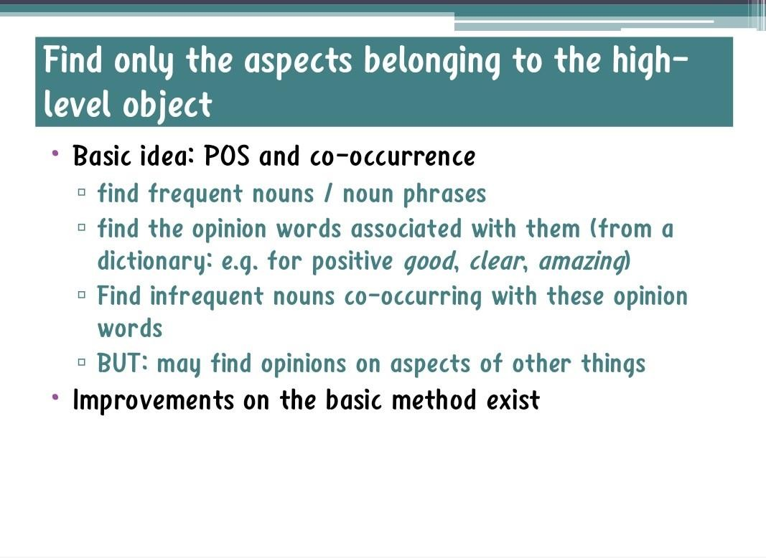



**Fake News**



Identify the orientation of information in a piece of text



The andaman and Nicobar island renamed in

the honour of netaji Subhash chandra

Bose.

[ Genuine ]



India will be a

Superpower by 2050.

[ Predictory ]



Ganga is the longest

River in the world.

[ Fake ]

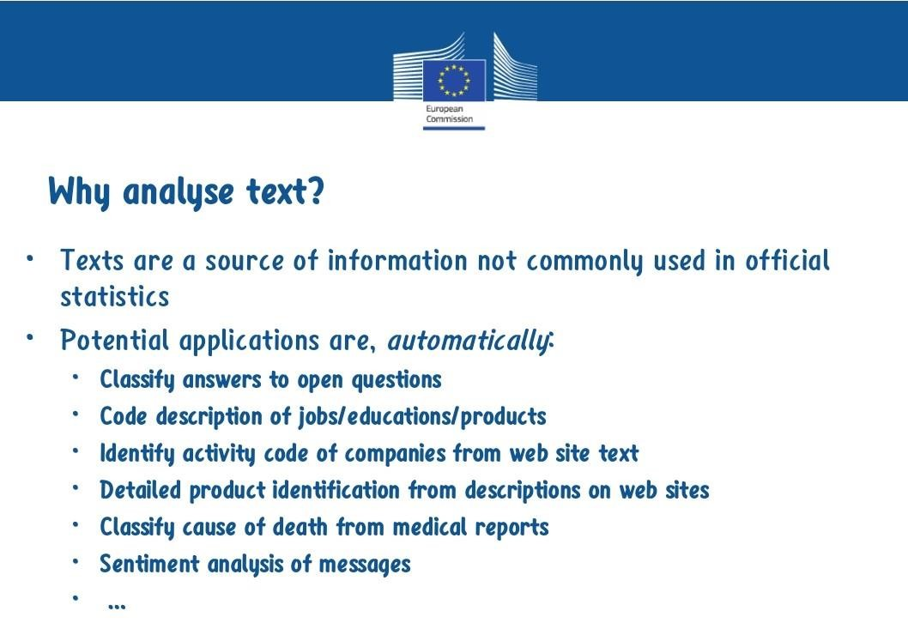



# Case Diagram



Wrong

Probability

Predictory

Correctness

Adjective

Noun

Sentences

Texts

#### Working of the tflite Model



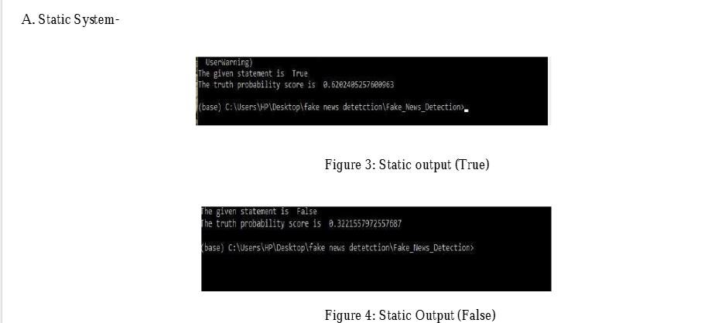

Working of the Android APP



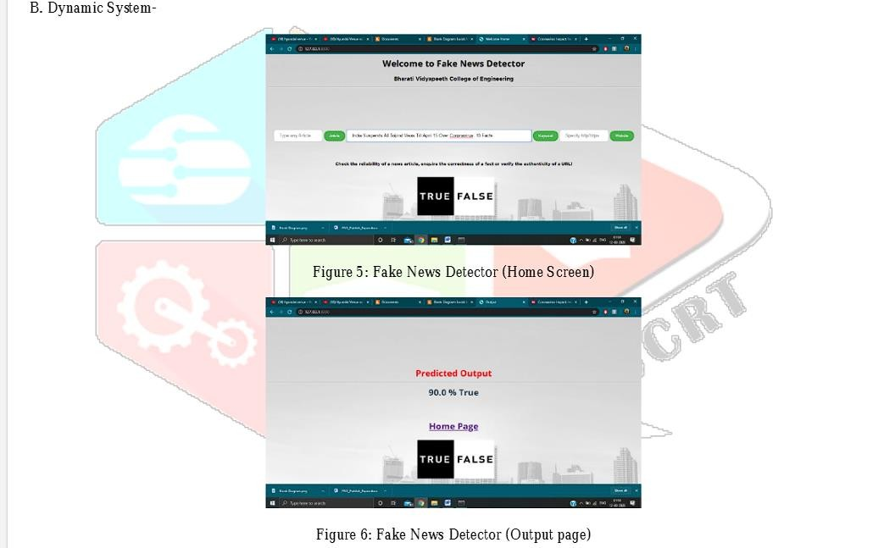

#### Areas To Be covered for Fake News Detection



🠶 Long Short-Term Memory (LSTM)

🠶 Recurrent Neural Networks

🠶 Word Embeddings

🠶 Convolutional Neural Networks

🠶 DropOut

🠶 Padding

🠶 TensorFlow.Keras

🠶 Average Pooling and Pooling Layers

🠶 Adam Optimizer

Long Short-Term Memory (LSTM)



**Long short-term memory** (**LSTM**) is an artificial [**recurrent neural network**](https://en.wikipedia.org/wiki/Recurrent_neural_network)(RNN)

architecture used in the field of [**deep learning**](https://en.wikipedia.org/wiki/Deep_learning). Unlike standard [**feedforward neural networks**](https://en.wikipedia.org/wiki/Feedforward_neural_network), LSTM has feedback connections. It can not only process single data points (such as images), but also entire sequences of data (such as speech or video). For example, LSTM is applicable to tasks such as [unsegmented, connected **handwriting**](https://en.wikipedia.org/wiki/Handwriting_recognition)

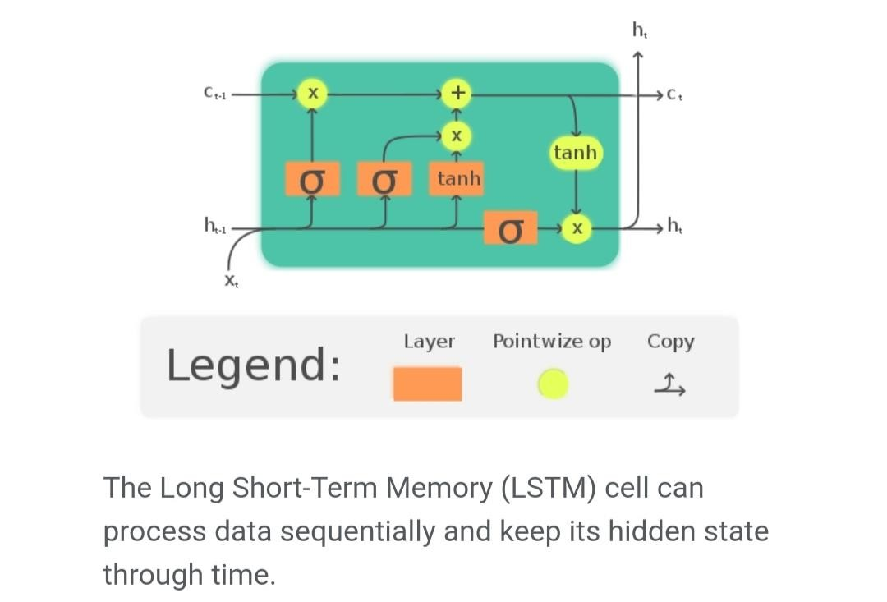[**recognition,**](https://en.wikipedia.org/wiki/Handwriting_recognition) [**speech recognition**](https://en.wikipedia.org/wiki/Speech_recognition) [and](https://en.wikipedia.org/wiki/Handwriting_recognition) anomaly detection in network traffic or IDSs (intrusion detection systems).

#### Recurrent Neural Networks



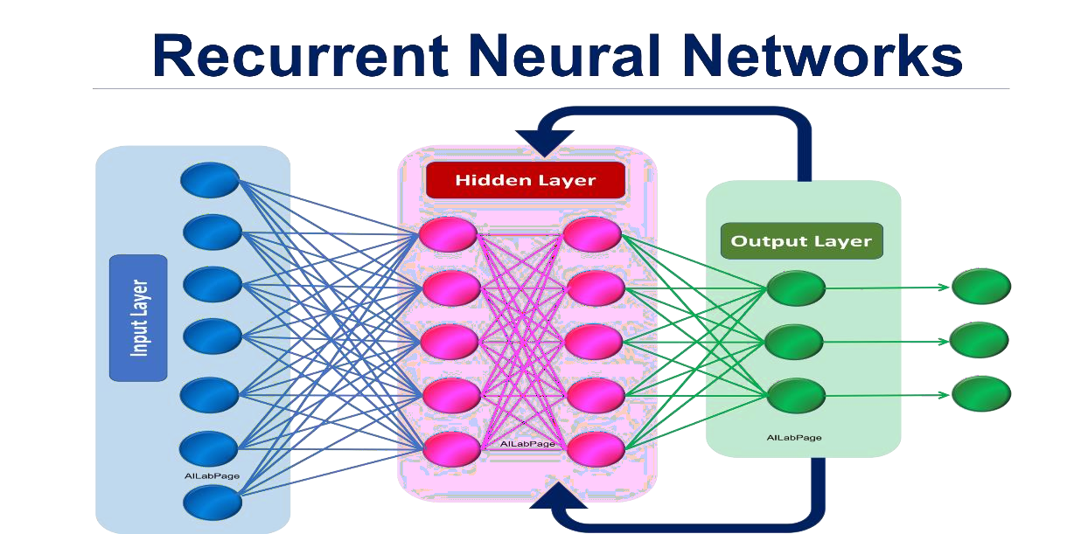A **recurrent neural network** (**RNN**) is a class [of **artificial neural**](https://en.wikipedia.org/wiki/Artificial_neural_network)

[**networks** where](https://en.wikipedia.org/wiki/Artificial_neural_network) connections

between nodes form

a [**directed graph**](https://en.wikipedia.org/wiki/Directed_graph) along a temporal sequence. This allows it to exhibit temporal dynamic behavior. Derived [from **feedforward neural networks,** RNNs can use](https://en.wikipedia.org/wiki/Feedforward_neural_networks) their internal state (memory) to process variable length sequences of inputs. This makes them applicable to tasks such as unsegmented, [connected **handwriting**](https://en.wikipedia.org/wiki/Handwriting_recognition)[**recognition** or **speech recognition**.](https://en.wikipedia.org/wiki/Speech_recognition)

#### Word Embedding

🠶 [In **natural language processing** (NLP),](https://en.wikipedia.org/wiki/Natural_language_processing) **Word embedding** is a term used for the representation of words for text analysis, typically in the form of a real-valued vector that encodes the meaning of the word such that the words that are closer in the vector space are expected to be similar in meaning. Word embeddings can be obtained using a set [of **language**](https://en.wikipedia.org/wiki/Language_model)



[**modeling** and **feature learning** techniques w](https://en.wikipedia.org/wiki/Feature_learning)here words or phrases from the vocabulary are mapped to [**vectors**](https://en.wikipedia.org/wiki/Vector_(mathematics)) of [**real numbers**](https://en.wikipedia.org/wiki/Real_numbers).

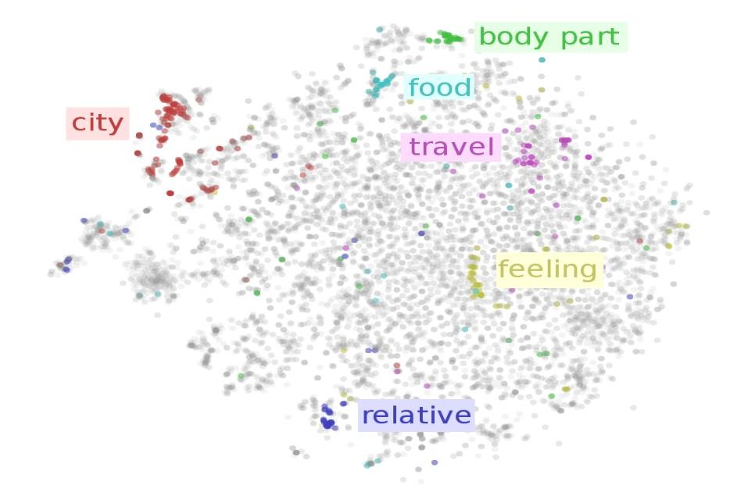

Methods to generate this mapping [include **neural**](https://en.wikipedia.org/wiki/Neural_net_language_model)

[**networks**, **dimensionality reduction** on the word **co-**](https://en.wikipedia.org/wiki/Dimensionality_reduction)[**occurrence matrix,** proba](https://en.wikipedia.org/wiki/Co-occurrence_matrix)bilistic models, explainable knowledge base method, and explicit representation in terms of the context in which words appear.

Convolutional Neural Networks



In [**deep learning**](https://en.wikipedia.org/wiki/Deep_learning), a **convolutional neural network** (**CNN**, or **ConvNet**) is a class

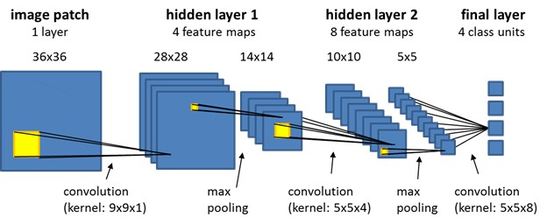

of [**deep neural network**](https://en.wikipedia.org/wiki/Deep_neural_network), most commonly applied to analyze visual imagery. They are also known as **shift invariant** or **space invariant artificial neural**

**networks** (**SIANN**), based on the shared-weight architecture of the convolution kernels or filters that slide along input features and provide

translation [**equivariant**](https://en.wikipedia.org/wiki/Equivariant_map) responses known as feature maps. Counter-intuitively, most convolutional neural networks are only [**equivariant**](https://en.wikipedia.org/wiki/Equivariant_map), as opposed

[to **invariant,** to translation. They have applications in **image and video**](https://en.wikipedia.org/wiki/Computer_vision)[**recognition, recommender systems, image classification, image**](https://en.wikipedia.org/wiki/Image_segmentation)[**segmentation, medical image analysis, natural language processing, brain- computer interfaces**, and financial](https://en.wikipedia.org/wiki/Brain%E2%80%93computer_interface) [**time series**](https://en.wikipedia.org/wiki/Time_series)[**.**](https://en.wikipedia.org/wiki/Brain%E2%80%93computer_interface)

#### Drop Out

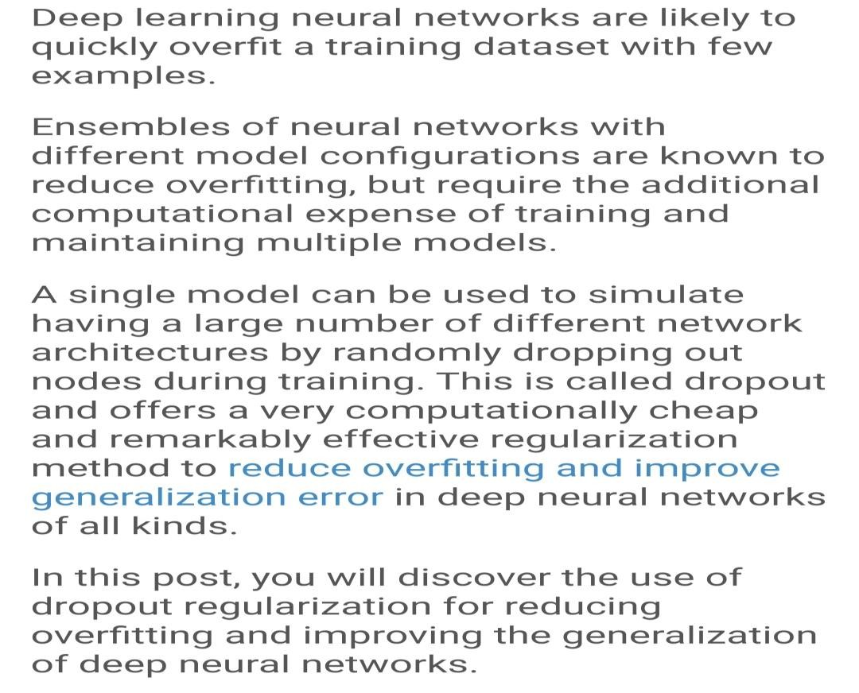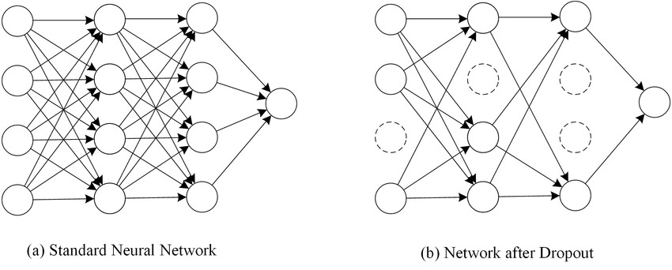

Adam Optimizer

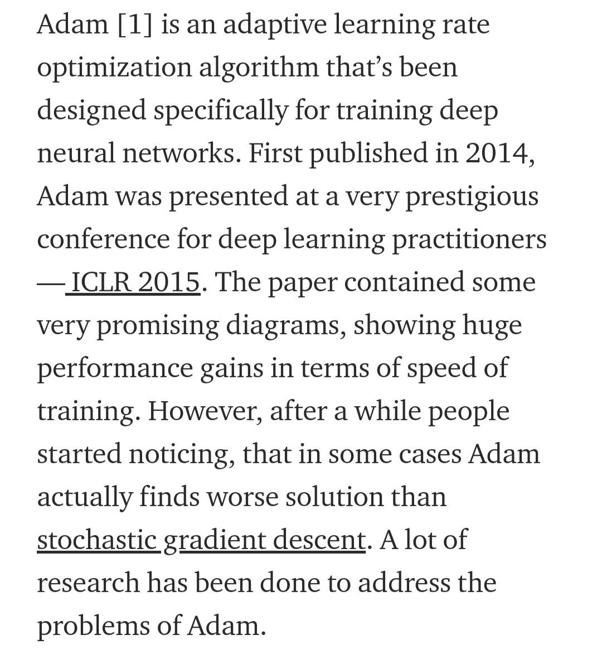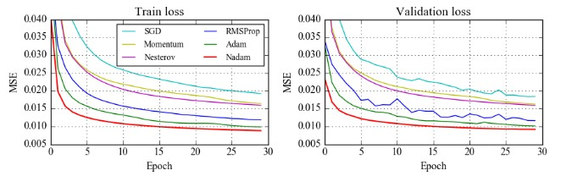

#### Properties Of Adam Optimizer



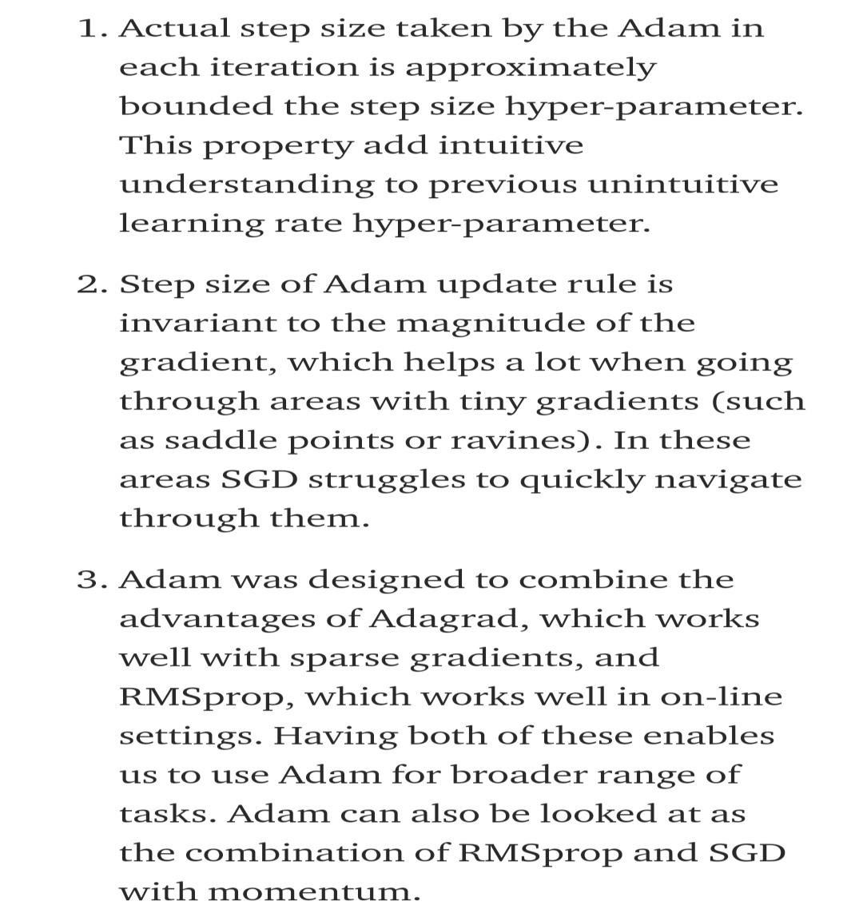

Keras

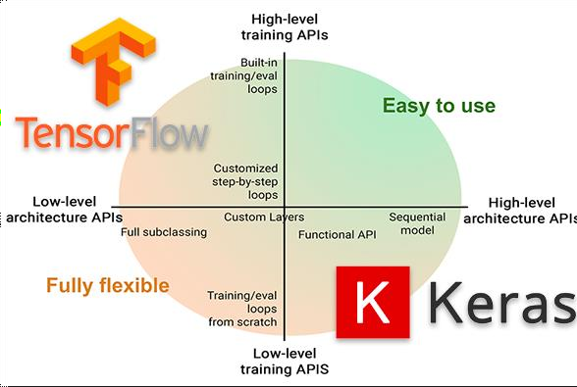

#### Pooling Layer and Average Pooling

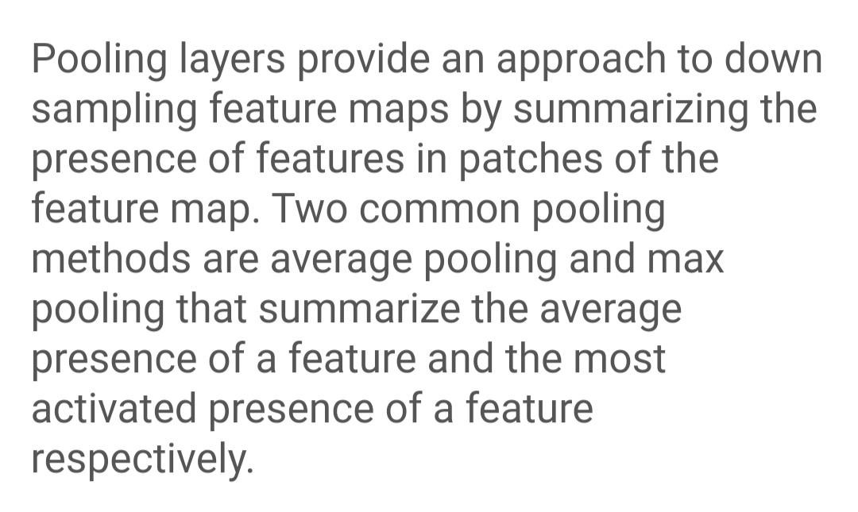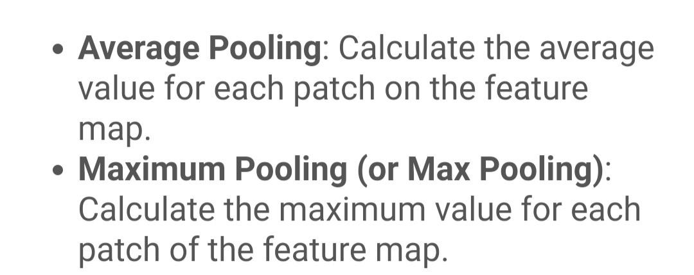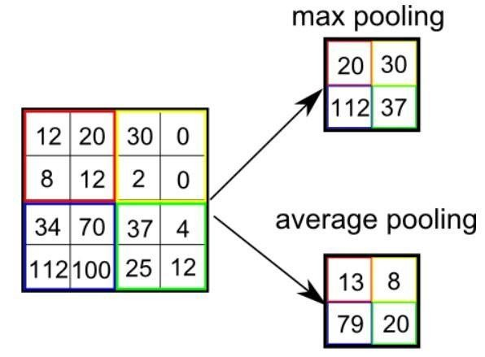

Padding

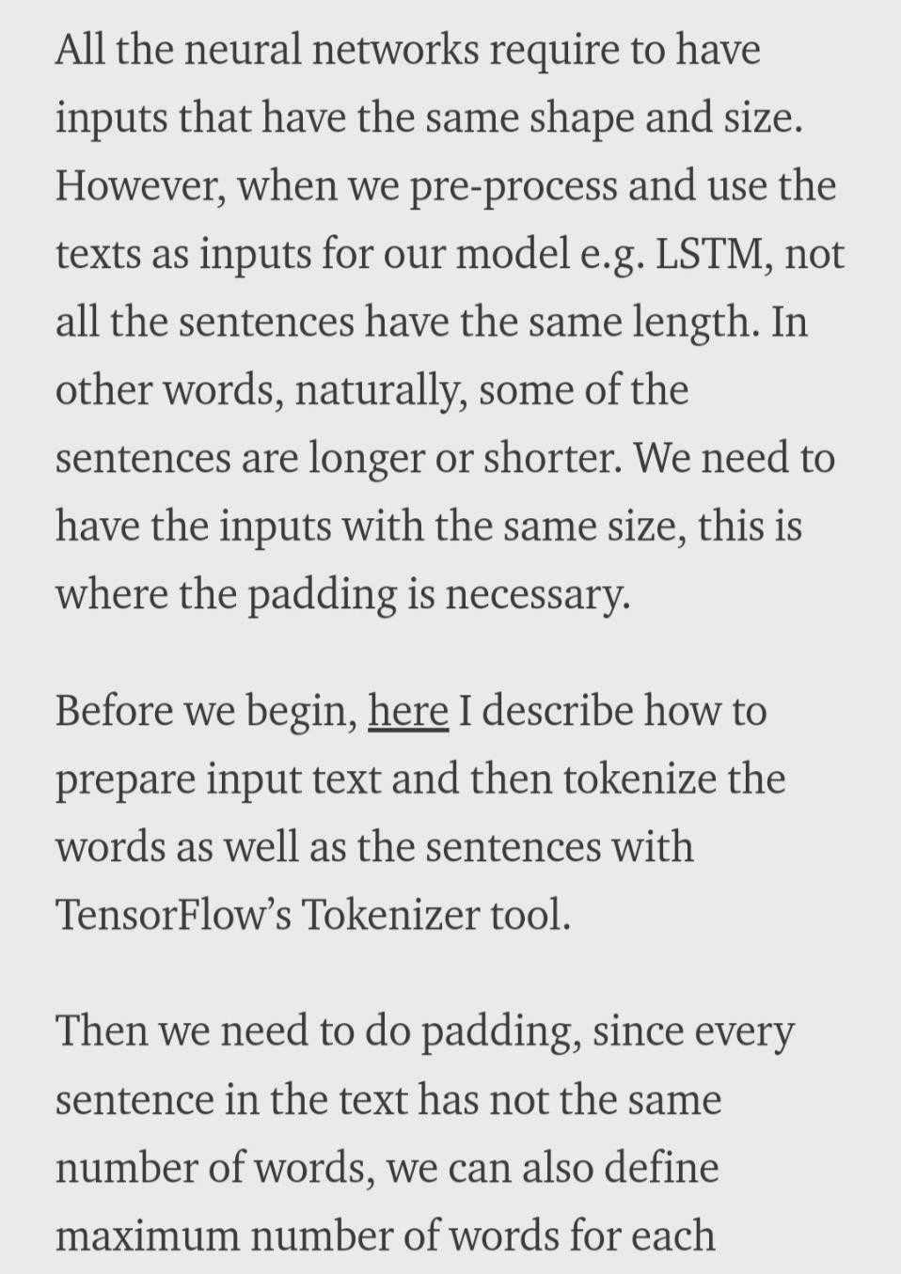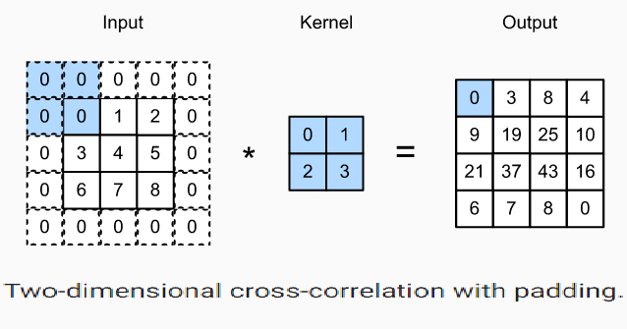

**Software Specifications**

|  |  |  |
| --- | --- | --- |
| 🠶 | **FRONT END** | **: Android Studio** |
| 🠶 | **BACK END** | **: tflite, Python, Kotlin, Pandas** |
| 🠶 | **DataSets** | **: Kaggle** |
| 🠶 | **PLATFORM** | **: Windows** |

### RESULT



Implementation was done using the above algorithms with Vector features- Count Vectors and Tf-Idf vectors at Word level and N gram level.

Accuracy was noted for all models.

We used K-fold cross validation technique to improve the effectiveness of the models.

1. Dataset split using K-fold cross validation This cross-validation technique was used for splitting the dataset randomly into k- folds. (k-1) folds were used for building the model while kth fold was used to check the effectiveness of the model. This was repeated until each of the k-folds served as the test set. I used 3- fold cross validation for this experiment where 67% of the data is used for training the model and remaining 33% for testing.
2. Confusion Matrices for Static System After applying various extracted features (Bag-of-words, Tf-Idf. N-grams) on three different classifiers (Naïve bayes, Logistic Regression and Random Forest), their confusion matrix showing actual set and predicted sets

**CONCLUSION AND FUTURE SCOPE**



In the 21st century, the majority of the tasks are done online.

Newspapers that were earlier preferred as hard-copies are now being substituted by applications like Facebook, Twitter, and news articles to be read online.

Whatsapp’s forwards are also a major source.

The growing problem of fake news only makes things more complicated and tries to change or hamper the opinion and attitude of people towards use of digital technology.

When a person is deceived by the real news two possible things happen- People start believing that their perceptions about a particular topic are true as assumed.

Thus, in order to curb the phenomenon, we have developed our Fake news Detection system that takes input from the user and classify it to be true or fake.

To implement this, various NLP and Machine Learning Techniques have to be used.

The model is trained using an appropriate dataset and performance evaluation is also done using various performance measures.

The best model, i.e. the model with highest accuracy is used to classify the news

headlines or articles.

As evident above for static search, our best model came out to be Logistic Regression with an accuracy of 65%.

Hence we then used grid search parameter optimization to increase the performance of logistic regression which then gave us the accuracy of 75%.

Hence we can say that if a user feed a particular news article or its headline in our

model, there are 75% chances that it will be classified to its true nature.

The user can check the news article or keywords online; he can also check the authenticity of the website.

The accuracy for dynamic system is 93% and it increases with every iteration.

We intend to build our own dataset which will be kept up to date according to the latest news.

All the live news and latest data will be kept in a database using Web Crawler and

online database.

References



[🠶 https://www.GeeksforGeeks.org/](https://www.geeksforgeeks.org/)

[🠶 https://www.python.org/](https://www.python.org/)

🠶 https://[www.kaggle.com/](http://www.kaggle.com/)

[🠶 https://docs.python.org/3/tutorial/](https://docs.python.org/3/tutorial/)

[🠶 https://www.google.com/](https://www.google.com/)

[🠶 https://www.Wikipedia.org/](https://www.wikipedia.org/)



# Thank You

